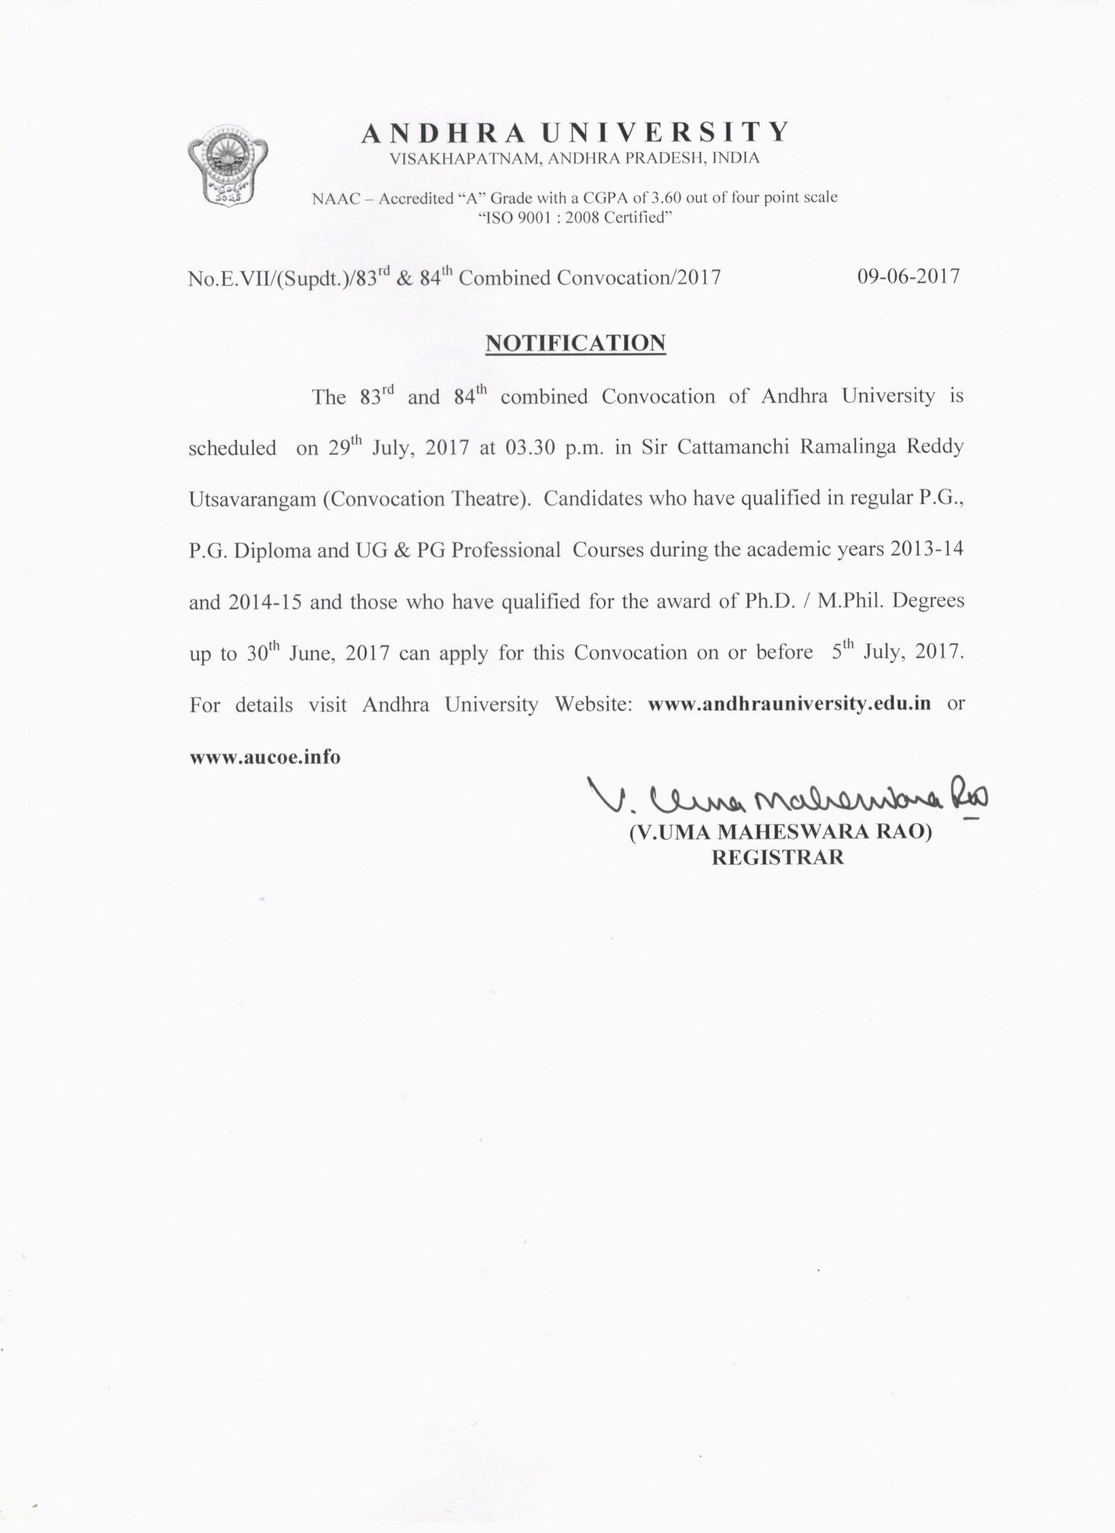

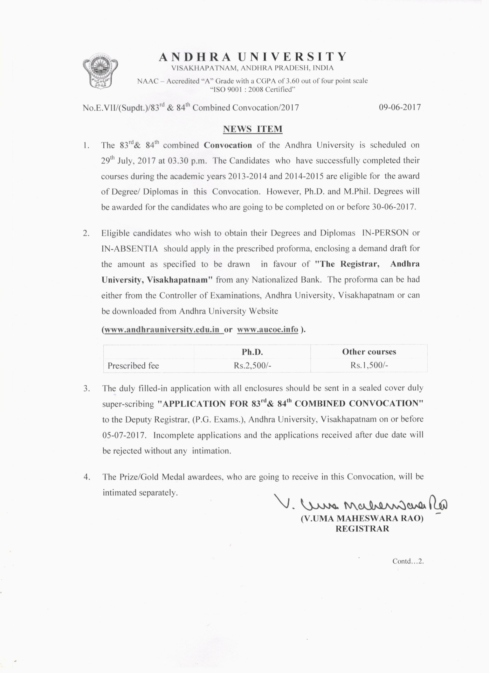

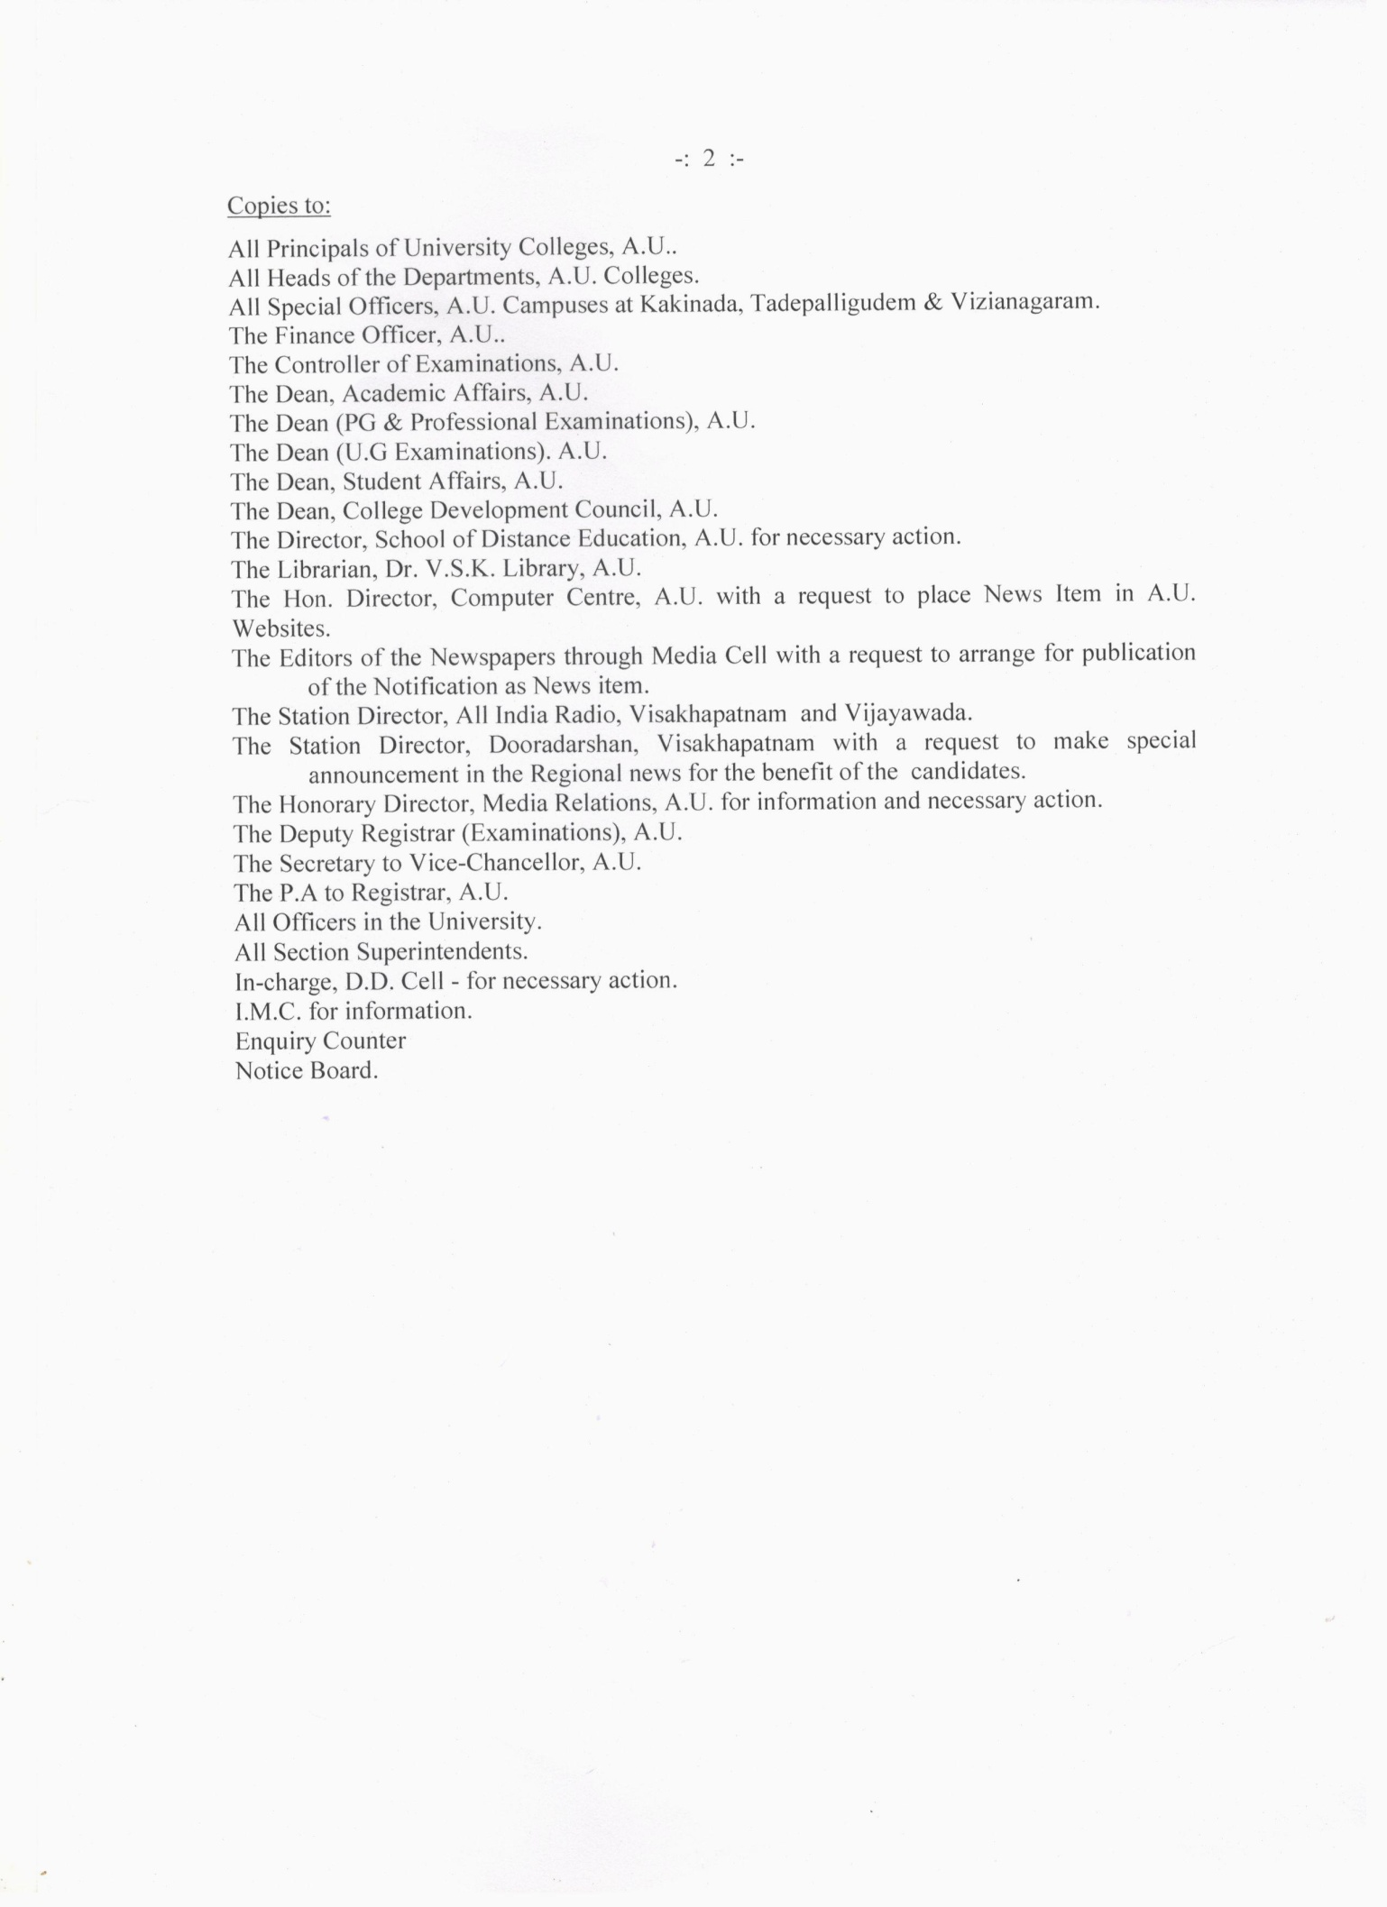

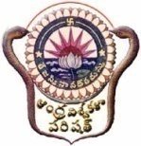
A N D H R A U N I V E R S I T Y

Affix latest passport size colour photograph
VISAKHAPATNAM, ANDHRA PRADESH, INDIA
NAAC – Accredited “A” Grade with a CGPA of 3.60 out of four point scale
“ISO 9001 : 2008 Certified”

APPLICATION FOR 83rd & 84th COMBINED CONVOCATION
(to be held on 29th July, 2017)

1 | Degree for which application is made | : | Ph.D. / M.Phil. / P.G. / P.G. Diploma /  UG & PG Professional Courses
2 | Full name of the candidate  (as per the S.S.C. in capital letters) | :
3 | Gender | : | MALE / FEMALE
4 | Address for Communication | : | Mobile:  E-mail:
5 | Particulars of Examination passed
5 | i) Register No. | :
5 | ii) Course | :
5 | iii) Month & Year of passing | :
5 | iv) Class obtained | :
5 | v) College studied | :
6 | Candidate wants to take Degree | : | IN-PERSON / IN-ABSENTIA

Station:
Date: SIGNATURE OF THE CANDIDATE
Note:
1. Successful candidates of 2013-14 & 2014-15 academic years are only eligible to apply.
2. Ph.D. and M.Phil. Degrees will be awarded for the candidates who are going to be completed on or before 30-06-2017.
3. Candidates should enclose their attested copy of S.S.C., lower degree & award proceedings in case of M.Phil./Ph.D.
4. Candidates applying for more than one Degree/Diploma should submit separate applications.
5. Prescribed fee: Ph.D. M.Phil. UG/PG/Professional Courses
Rs.2,500/- Rs.1,500/- Rs.1,500/-
[Payment be made by way of Demand Draft drawn in favour of the 'Registrar, Andhra University, Visakhapatnam']
6. Last date for receipt of duly filled in applications is 05-07-2017.

